**First program:**

<!DOCTYPE html>

<html>

<head>

<title>Table</title>

</head>

<body>

<table border="2" cellspacing="0" cellpadding="5" width="35%">

<tr><td rowspan="2">HTML Test 10</td><td>HTML Test 20</td><td>HTML Test 30</td></tr>

<tr><td>HTML Test 21</td><td>HTML Test 31</td></tr>

<tr><td>HTML Test 12</td><td rowspan="2">HTML Test 22</td><td>HTML Test 32</td></tr>

<tr><td>HTML Test 13</td><td>HTML Test 33</td></tr>

<tr><td>HTML Test 14</td><td>HTML Test 24</td><td rowspan="2">HTML Test 34</td></tr>

<tr><td>HTML Test 15</td><td>HTML Test 25</td></tr>

</table>

</body>

</html>

**Output:**

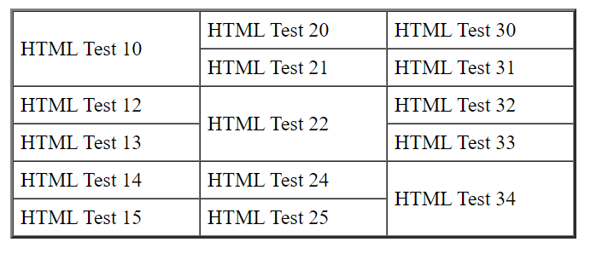

**Program 4:**

<!DOCTYPE html>

<html>

<head>

<title>Heading</title>

<style>

h1 { background-color: Green; color:purple;}

</style>

</head>

<body>

<h1>Heading 1</h1>

<h1>Heading 2</h1>

<h1>Heading 3</h1>

<h1>Heading 4</h1>

<h1 style="background-color: Blue; color: orange;">Heading 5 </h1>

<h1>Heading 6</h1>

<h1>Heading 7</h1>

<h1>Heading 8</h1>

<h1>Heading 9</h1>

<h1>Heading 10</h1>

</body>

</html>

**Output:**

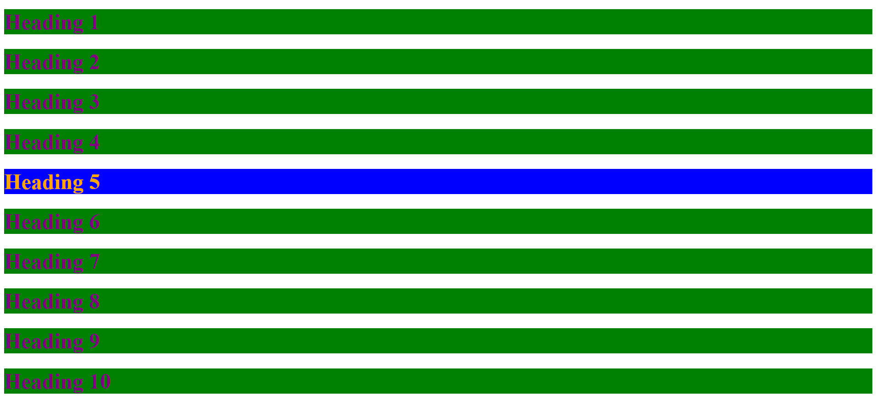

**Program 3:**

<!DOCTYPE html>

<html>

<head>

<title>color Table</table></title>

<style>

tr { text-align: center;

font-size: 20px;}

</style>

</head>

<body>

<!-- <table borer="1" cellspacing="0" cellpadding="5" width="35%">

<tr height="100" >

<td style="background-color:red ;"><b>Page 1</b></td>

<td style="background-color: green;"><b>Page 2</b></td>

</tr>

<tr height="100" >

<td style="background-color: rgb(94, 94, 233);"><b>Page 3</b></td>

<td style="background-color:rgb(240, 240, 11);"><b>Page 4</b></td>

</tr>

</table> -->

<img src="C:\Users\hema.s\Downloads\html6\html\color.PNG" usemap="#table_color" width="400" height="379">

<map name="table_color">

<area shape="rect" coords="11,3,299,278" alt="Page 1" href="C:\Users\hema.s\Downloads\html6\html\Page 1.html">

<area shape="rect" coords="308,8,598,276" alt="Page 2" href="C:\Users\hema.s\Downloads\html6\html\Page 2.html">

<area shape="rect" coords="9,286,293,556" alt="Page 3" href="C:\Users\hema.s\Downloads\html6\html\Page 3.html">

<area shape="rect" coords="308,290,600,561" alt="Page 4" href="C:\Users\hema.s\Downloads\html6\html\page 4.html">

</map>

</body>

</html>

**Page 1.html:**

<!DOCTYPE html>

<html>

<head>

<title>Page 1</title>

</head>

<body>

<h1>Page 1</h1>

</body>

</html>

**Page 2.html:**

<!DOCTYPE html>

<html>

<head>

<title>Page 2</title>

</head>

<body>

<h1>Page 2</h1>

</body>

</html>

**Page 3.html:**

<!DOCTYPE html>

<html>

<head>

<title>page 3</title>

</head>

<body>

<h1>Page 3</h1>

</body>

</html>

**Page 4.html:**

<!DOCTYPE html>

<html>

<head>

<title>page 4</title>

</head>

<body>

<h1>Page 4</h1>

</body>

</html>

**Output:**

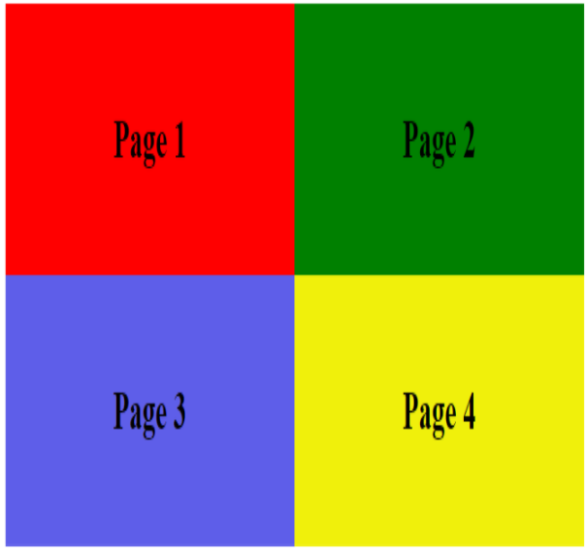









**Program:5**

<!DOCTYPE html>

<html>

<head>

<title>styles</title>

<style>

*{background-color:black}

h1,h2,h3,h4,h5,h6,p,pre,table { margin:none; border:1px solid red;}

h1,h2,h3,h4,h5,h6,p,pre,table{color:blueviolet;text-align: center;}

h1,h2,h3,h4,h5,h6,p,pre,table{font-family: 'Courier New';}

div{ margin:10px,20px,10px,20px;}

</style>

</head>

<body>

<h1>heading 1</h1>

<h2>heading 2</h2>

<h3>heading 3</h3>

<h3>heading 4</h3>

<h3>heading 5</h3>

<h3>heading 6</h3>

<p>paragraph</p>

<div>

<p> Div paragraph</p>

</div>

<hr/>

<table boder="10" cellspacing="0" cellpadding="5" width="35%">

<tr><td>1</td><td>2</td></tr>

<tr><td>3</td><td>4</td></tr>

</table>

<pre>pre formatted </pre>

</body>

</html>

**Output:**

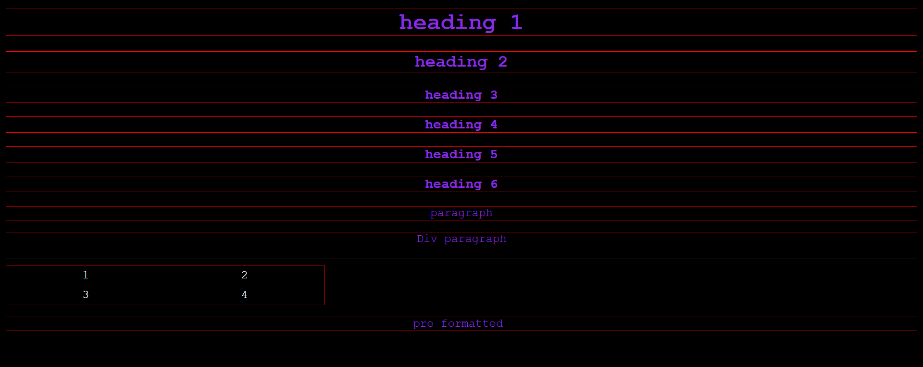

**Program 2:**

**Page 1.html:**

<!DOCTYPE html>

<html>

<head>

<title>navigate</table></title>

</head>

<body>

<a id="top1"></a> <!-- mark the address for this location/line or Bookmark -->

<a rel="C:\Users\hema.s\Downloads\html6\html\page_2.html" ></a>

<a href="#center1">Go to center</a>

<P>LINE 1: paragrapgh</P>

<P>LINE 2: paragrapgh</P>

<P>LINE 3: paragrapgh</P>

<P>LINE 4: paragrapgh</P>

<P>LINE 5: paragrapgh</P>

<P>LINE 6: paragrapgh</P>

<P>LINE 7: paragrapgh</P>

<P>LINE 8: paragrapgh</P>

<P>LINE 9: paragrapgh</P>

<P>LINE 10: paragrapgh</P>

<P>LINE 11: paragrapgh</P>

<P>LINE 12: paragrapgh</P>

<P>LINE 13: paragrapgh</P>

<P>LINE 14: paragrapgh</P>

<P>LINE 15: paragrapgh</P>

<P>LINE 16: paragrapgh</P>

<P>LINE 17: paragrapgh</P>

<P>LINE 18: paragrapgh</P>

<a href="C:\Users\hema.s\Downloads\html6\html\page_2.html"></a>

<a id="center1"></a> <!-- mark the address for this location/line or Bookmark -->

<a href="#bottom1">Go to bottom</a>

<P>LINE 19: paragrapgh</P>

<P>LINE 20: paragrapgh</P>

<P>LINE 21: paragrapgh</P>

<P>LINE 22: paragrapgh</P>

<P>LINE 23: paragrapgh</P>

<P>LINE 24: paragrapgh</P>

<P>LINE 25: paragrapgh</P>

<P>LINE 26: paragrapgh</P>

<P>LINE 27: paragrapgh</P>

<P>LINE 28: paragrapgh</P>

<P>LINE 29: paragrapgh</P>

<P>LINE 30: paragrapgh</P>

<P>LINE 31: paragrapgh</P>

<P>LINE 32: paragrapgh</P>

<P>LINE 33: paragrapgh</P>

<P>LINE 34: paragrapgh</P>

<P>LINE 35: paragrapgh</P>

<P>LINE 36: paragrapgh</P>

<P>LINE 37: paragrapgh</P>

<P>LINE 38: paragrapgh</P>

<P>LINE 39: paragrapgh</P>

<P>LINE 40: paragrapgh</P>

<a href="C:\Users\hema.s\Downloads\html6\html\page_2.html"></a>

<a id="bottom1"></a> <!-- mark the address for this location/line or Bookmark -->

<a href="#top1">Go to Top</a>

</body>

</html>

**Page 2.html**

<!DOCTYPE html>

<html>

<head>

<title>navigate</table></title>

</head>

<body>

<a id="top1"></a> <!-- mark the address for this location/line or Bookmark -->

<a rel="C:\Users\hema.s\Downloads\html6\html\page_1.html" ></a>

<a href="#center1">Go to center</a>

<P>LINE 1: paragrapgh</P>

<P>LINE 2: paragrapgh</P>

<P>LINE 3: paragrapgh</P>

<P>LINE 4: paragrapgh</P>

<P>LINE 5: paragrapgh</P>

<P>LINE 6: paragrapgh</P>

<P>LINE 7: paragrapgh</P>

<P>LINE 8: paragrapgh</P>

<P>LINE 9: paragrapgh</P>

<P>LINE 10: paragrapgh</P>

<P>LINE 11: paragrapgh</P>

<P>LINE 12: paragrapgh</P>

<P>LINE 13: paragrapgh</P>

<P>LINE 14: paragrapgh</P>

<P>LINE 15: paragrapgh</P>

<P>LINE 16: paragrapgh</P>

<P>LINE 17: paragrapgh</P>

<P>LINE 18: paragrapgh</P>

<a href="C:\Users\hema.s\Downloads\html6\html\page_1.html"></a>

<a id="center1"></a> <!-- mark the address for this location/line or Bookmark -->

<a href="#bottom1">Go to bottom</a>

<P>LINE 19: paragrapgh</P>

<P>LINE 20: paragrapgh</P>

<P>LINE 21: paragrapgh</P>

<P>LINE 22: paragrapgh</P>

<P>LINE 23: paragrapgh</P>

<P>LINE 24: paragrapgh</P>

<P>LINE 25: paragrapgh</P>

<P>LINE 26: paragrapgh</P>

<P>LINE 27: paragrapgh</P>

<P>LINE 28: paragrapgh</P>

<P>LINE 29: paragrapgh</P>

<P>LINE 30: paragrapgh</P>

<P>LINE 31: paragrapgh</P>

<P>LINE 32: paragrapgh</P>

<P>LINE 33: paragrapgh</P>

<P>LINE 34: paragrapgh</P>

<P>LINE 35: paragrapgh</P>

<P>LINE 36: paragrapgh</P>

<P>LINE 37: paragrapgh</P>

<P>LINE 38: paragrapgh</P>

<P>LINE 39: paragrapgh</P>

<P>LINE 40: paragrapgh</P>

<a href="C:\Users\hema.s\Downloads\html6\html\page_1.html"></a>

<a id="bottom1"></a> <!-- mark the address for this location/line or Bookmark -->

<a href="#top1">Go to Top</a>

</body>

</html>

**Output:**

